iPhone Apps – Building Apps Without Coding
(unless I give you the code)
by Lynn Rosier

What will I need?
You will need a Mac computer with Xcode installed. It would be best to have a Mac computer with Mavericks and Xcode 5 or later. Xcode is a free download (although you must register) from the Mac App store or from developer.apple.com/devcenter/ios. It is important that you have a version of Xcode that supports storyboards (Xcode 4.2 or later with iOS5 or later). What are storyboards?
From Apple's Website:

"Discover how Xcode's Interface Builder support for Storyboarding in iOS 5 makes designing your iOS apps so much easier. Storyboarding allows you to graphically arrange all your views within a single design canvas, where you can then define the app's logical flow, and even assign transition animations."

What is Xcode? (IDE)
Xcode is the development environment from Apple that is used to create apps and Mac programs.

What is the iOS Dev Center?
The iOS Dev Center is where you can find downloads, sample code, how to videos, etc. It is also where you go to create provisioning and distribution profiles for your apps. It is also where you manage your uploaded apps. (developer.apple.com/devcenter)

Can I put my apps that I create on my iPhone, iPod, or iPad?
You must become a registered iOS Developer in order to copy apps that you create to your iPhone/iPad/iPod. The cost is $99 + tax. This allows you to install your app on a maximum of 100 devices for testing, as well as upload apps to the Apple review committee. You can register at developer.apple.com/devcenter/ios. You also get access to help videos, documents, etc.

What are some good books that you would recommend?
There are lots of books out there for iPhone development. I like the following books the best:
1) iPad iOS7 App Development from www.ebookfrenzy.com or www.amazon.com.
(this has several chapters on storyboards)
2) Programming in Objective-C by Stephen G. Kochan (to learn how to program)
3) The iPhone Developer's Cookbook by Erica Sadun. (to learn how to program)

Do you have a website that would help?
Yes.
www.autowaredevelopment.com/iPhoneHelp
I have many materials on my website and I will be adding more materials in the near future.
Are there any other development environments besides Xcode?
Yes, but …
Some general things NOT to do in your project.
(unless you know how to do it the correct way)
1) Don’t rename files
2) Don’t take out code that has been written for you by Apple.
3) Don't try to publish an app that has downloaded images, songs, etc. Create your own!
4) Don't mess with the project folder than contains your app files
Xcode Overview (IDE)
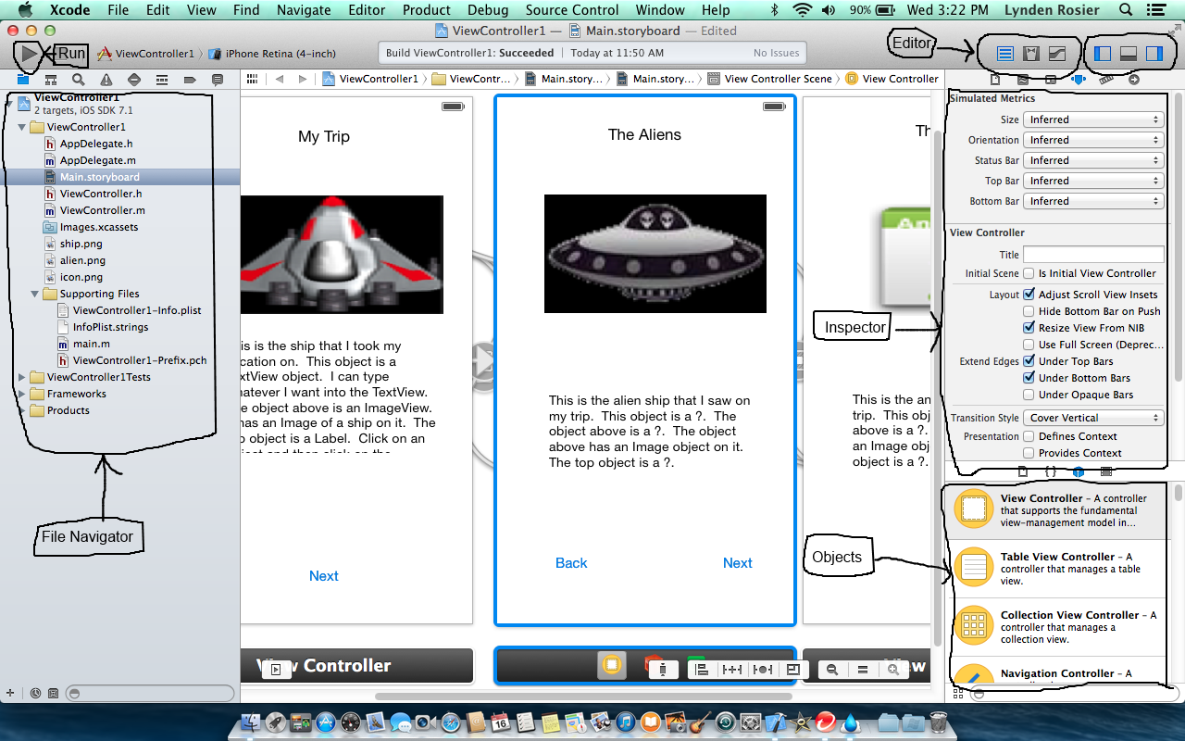

I) Creating a Simple App with a Storyboard

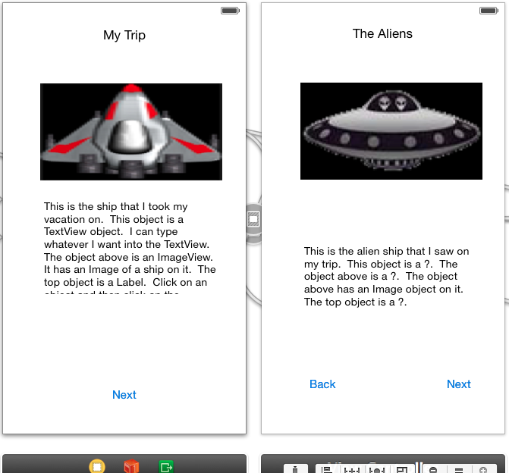

Stop and Listen
* Creating a project (File New Project) (select a Single View project)
* A look at the View Controller in the storyboard file (it contains a View object)
* What are the .h and .m files? (it’s for writing code that controls the view or scene!)
* An overview of the Xcode Interface (panels and buttons)
Navigational Panel (shows files of the project ) (on the left)
Editor (center) Panel (for your storyboard or code)
Inspector (Attributes) Panel (attributes (or properties) of buttons, labels, etc.)
Object Panel (contains buttons, labels, etc. to add to your view)
* How to run my app in the simulator (click on the Run arrow in the upper left corner)
* How to check the attributes of my View Controller and my View (canvas)
A View is a visual object used to create the user interface.
Click on the View and then select the attributes inspector tab.
A ViewController allows us to control the View
Click on the ViewController and then select the attributes inspector tab
* How to add objects to my View (drag and drop from the Object Panel)
(you must be zoomed in or you cannot drop objects on the view)
A Label (UILabel)
A TextView (UITextView)
An ImageView (UIImageView) and an image
Adding an image to the ImageView
(drag and drop an image to the Navigational Panel and then change the attributes of the ImageView)
A Button (UIButton)
(double click on the button to enter the text)

A Swipe Gesture (drag from the object panel to the view)
(this will show up at the bottom of the view controller)
You will need to change the attributes in order to allow it
function properly.
Now it's your turn!

See if you can create the above project, create the first view, and run the app. Don't worry about the second view yet, we
will do that shortly.
II. Creating a Second View Controller and Linking
Stop and Listen
* Adding a second View Controller
(drag a View Controller from the Object Panel to the storyboard)
* Adding objects to the View
(drag a Label from the Object Panel to the view)
(drag an ImageView from the Object Panel to the view)
(drag a Button from the Object Panel to the view)
(drag a Swipe Gesture from the Object Panel to the view)
* Linking the buttons to the view controller
(control + drag the button to the view and choose modal from the popup)
* Linking the swipe gestures
(control + drag the swipe to the view and choose modal from the popup)

Now it's your turn!
Can you add a third controller, drag objects to it, and connect it as well? If you have time,
give it a try!

(btw, this is not a great way to link pages together, so later we will look at better solutions,
although the best solutions involve writing code)

III. Linking View Controllers with a Navigation Controller

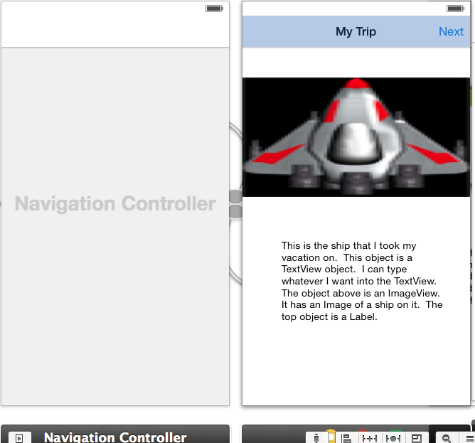

Stop and Listen
* Creating a new Project (File New Project)
* Embedding a Navigation Controller in our View Controller
Editor Embed In Navigation Controller
(Do NOT drag a Navigational Controller from the Object Panel)
* Adding objects to our View
(drag objects from the Object Panel to the View)
(change the text in the Navigation Controller (double click in the middle of it)
(drag a BarButtonItem to the Navigation Controller) (right hand side)
* Adding a second View Controller and Linking (choose Push)
(drag a View Controller from the Object Panel to the storyboard)
(drag a BarButtonItem to the Navigation Controller)
(Control + drag from the BarButtonItem to this new View and choose Push)
* Adding objects to our View
(drag objects from the Object Panel to the View)
* Adding a third View Controller and Linking (choose Push)
(drag a View Controller from the Object Panel to the storyboard)
(Control + drag from the BarButtonItem to this new View and choose Push)
* Adding objects to our View
(drag objects from the Object Panel to the View)
* Adding a swipe gesture
* Adding different transitions (it's an attribute of the View Controller)
Now it's your turn!

IV. Linking View Controllers with a Tab Bar Controller

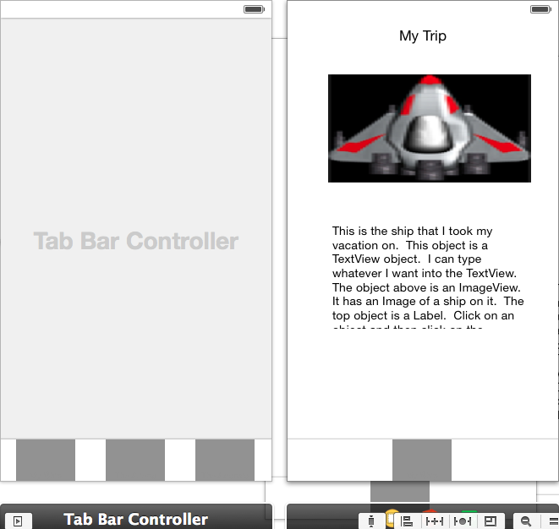

* Creating a new Project (File New Project)
* Embedding a Tab Bar Controller in our View Controller
Editor Embed In Tab Bar Controller
* Adding objects to our View
(drag objects from the Object Panel to the View)
(click on the tab bar item and the attributes to change the name)
* Adding a second View Controller and Linking
(drag a View Controller from the Object Panel to the storyboard)
(Control + drag from the Tab Bar Controller to this new View,
and select view controllers from the pop up)
* Adding objects to our View
(drag objects from the Object Panel to the View)
(click on the tab bar item and the attributes to change the name)
* Adding a third View Controller and Linking
(drag a View Controller from the Object Panel to the storyboard)
(Control + drag from the Tab Bar Controller to this new View,
and select view controllers from the pop up)
* Adding objects to our View
(drag objects from the Object Panel to the View)
(click on the tab bar item and the attributes to change the name)

Now it's your turn!
V. Let's Play Some Music!
Well, I know I said no coding, but what if I give you the code?
*** Step 1: ***

Add the AVFoundation.framework class to your project:
(since the AVAudioPlayer class that you will need is in this framework)

1) Click on the project target in the Project Navigator Panel (on the left at the top)
2) Click on the Build Phases tab in the main panel (center area)(scroll down)
3) Click on the + in the Link Binary with Libraries section
(you may need to click on the right arrow to open this section)
4) Select the AVFoundation.framework and click on the Add button

*** Step 2: ***
Click on the ViewController.h file and in the editor add the following code:
(You can get this code from my website or you can type it in. However, it must be exact and the code is case sensitive.)

ADD THE FOLLOWING STATEMENT ABOVE THE @interface ViewController line
#import <AVFoundation/AVFoundation.h>

@interface ViewController : UIViewController (above this existing line)

ADD THE FOLLOWING STATEMENT JUST ABOVE THE @end line
@property (strong, nonatomic) AVAudioPlayer *audioPlayer;

*** Step 3: ***

Click on the ViewController.h file and in the editor add the following code inside your viewDidLoad method right after the line [super viewDidLoad];

NSURL *url = [NSURL fileURLWithPath:
[[NSBundle mainBundle] pathForResource:@"MyFilename" ofType:@"mp3"]];

NSError *error;

_audioPlayer = [[AVAudioPlayer alloc]
initWithContentsOfURL:url error:&error];

if (error)
{
NSLog(@"Error in audioPlayer");
}
else
{
_audioPlayer.delegate = self;
[_audioPlayer prepareToPlay];
[_audioPlayer play];
}

*** Step 4: ***
We need some music!
You will need to drag and drop a music file into the Navigation Panel's supporting files. You will also need to specify the filename in the code above where it says @"MyFilename" and the type @"mp3".

VI. Creating an App with a Static Table
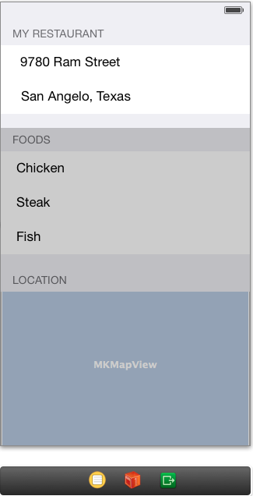

Let's do this one together!

1) Creating a new Project (File New Project)
2) Delete the ViewController .m and .h files
3) Delete the ViewController on the storyboard (but not the storeboard file!)
4) Drag and drop a Table View Controller from the object panel onto the storyboard
5) Add a new Objective c class (creates a .m and .h file for the TableViewController)
File -> New -> File
class StaticTableViewController (this is a name that you give it)
subclass UITableViewController
(and disable all check boxes)
6) Change the storyboard's TableViewController class name to StaticTableViewController (or whatever you called it)
Click on the storyboard's TableViewController icon and then click on the Inspector's Identity tab (it is to the left of the attributes tab).
Find the Custom Class section (top one) and choose the class name that you
used in the step above.
7) Change the TableView content to Static Cells, sections to 3, and its style to grouped (notice this is the TableView, not the controller)
Click on the TableView and click on the Inspector's attribute tab.
This may be hidden. If so, you will need to click on the arrow to show the
document outline (it's in the lower left corner of the Editor Panel (center).
9) Delete any rows from the TableView that you don't want
Click on the row in the TableView's section and press the Delete key
10) Add objects to the rows of the TableViewController
You can drag labels, text fields, imageviews, etc.
11) Erase all code after the #pragma mark in the view controller's .m file
12) Run your program
See if you can create an app of your own.

Some ideas!
These could be Navigational apps or Tab apps
Show different kinds of Animals
Show different kinds of Dogs
Show different kinds of Cats
Show Information about you, your hobbies, your family, your classes, etc.

Some General Things:

1) Changing the Text on an Object (UILabel, UITextView, etc.)
If you have an object on your view that displays text (UILabel, UITextView, etc.), you can change the text by double clicking on the object and then typing. You can also click once on the object, select the attributes tab on the Inspector panel, and then find the text attribute and change it

2) Setting the Image on an Object
If you have an object on your view that can display an image, you can set the image by clicking on the object, selecting the attributes tab on the Inspector panel, and selecting the image from the Image drop down box. The image must be copied to the supported files folder in the Navigational Panel (drag and drop it). Make sure you choose to copy it from the dialog box.

3) Case Sensitive
All code, class names, filenames, etc. are case sensitive.

4) Adding a .m and .h file for a ViewController
If you want to add code to handle a new ViewController, then you must create a .m and .h file and associate the view controller (on the storyboard) to that class name.
1) Add a new Objective c class (creates a .m and .h file for a ViewController)
File -> New -> File
class whateverViewController (or whatever you want to call it)
subclass UIViewController (or the type of view controller)
(and disable all check boxes)
2) Change the storyboard's ViewController class name to whateverViewController (to whatever you called it above)
Click on the storyboard's ViewController icon and click on the
Inspector's Identity tab.
Find the section Custom Class and choose your class name from the
dropdown box.

